
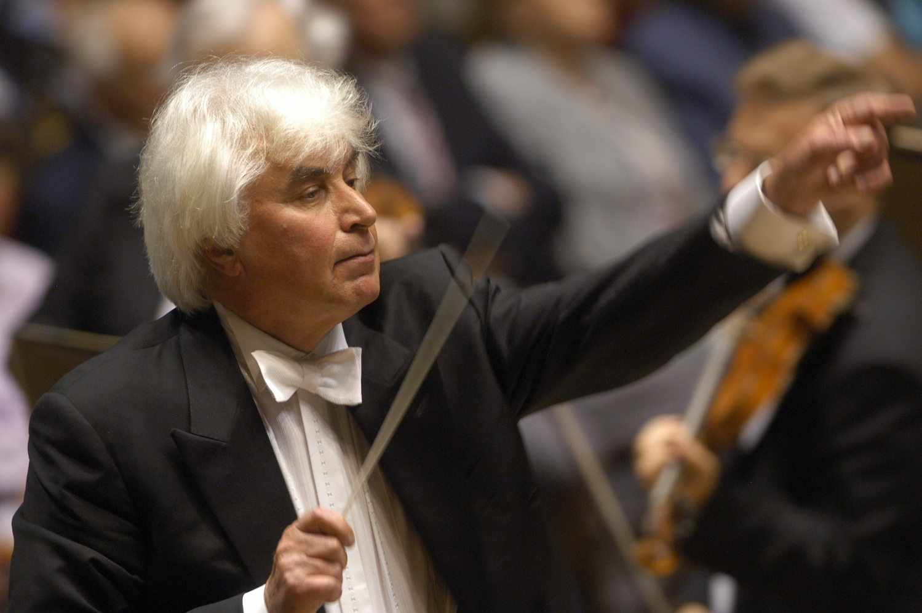

Dimitri Kitaenko
Biography (short form)

Dimitri Kitaenko is one of the great maestros of our time. For decades now he has regularly conducted prestigious orchestras across Europe, America and Asia.

Born in Leningrad (now St Petersburg), Dimitri Kitaenko studied at the famous Glinka School of Music and the Rimsky-Korsakov Conservatory before leaving to study with Leo Ginzburg in Moscow as well as Hans Swarowsky and Karl Österreicher in Vienna. In 1969 he won a prize at the first International Herbert von Karajan Conducting Competition and at the age of twenty-nine he was appointed principal conductor of the Stanislavsky Theatre in Moscow. In 1976 he assumed the post of principal conductor of the Moscow Philharmonic. In 1990 Dimitri Kitaenko moved to the West, successively becoming principal conductor of the Frankfurt Radio Symphony and the Bergen Philharmonic Orchestra, as well as principal guest conductor of the Danish National Symphony Orchestra. Since 2012 Dimitri Kitaenko has also been principal guest conductor of the Berlin Konzerthausorchester. In September 2015 he was named Conductor of Honor of the Qatar Philharmonic Orchestra.

Dimitri Kitaenko and the Cologne Gürzenich Orchestra, of which he has been honorary conductor since 2009, have together recorded the complete symphonic works of Shostakovich, Prokofiev, Tchaikovsky and Rachmaninoff. These recordings have been awarded countless international prizes and are considered important benchmark recordings. Their recording of Tchaikovsky's one-act opera Iolanta in 2015 with Olesya Golovneva, Alexander Vinogradov and Andrei Bondarenko in the lead roles caused a sensation. In autumn 2016 the complete recording of Tchaikovsky's ballet music to The Nutcracker and the Divertimento from Stravinsky's Le baiser de la fée were released on OehmsClassic. Dmitri Kitaenko's discography encompasses a total of more than 250 recordings, mostly with the Moscow Philharmonic Orchestra, the Frankfurt Radio Symphony, the Bergen Philharmonic Orchestra and the Danish National Symphony Orchestra.

In recognition of his life's work and outstanding recordings, including the complete symphonic works of Shostakovich, Prokofiev, Scriabin and Tchaikovsky, Dimitri Kitaenko received the "Lifetime Achievement Award" at the ICMA (International Classical Music Awards) in March 2015.

www.kitajenko.com
*
Version: September 2016

General Management: Vera van Hazebrouck | Van Hazebrouck Artists – P +49 172 4236370 – vera@hazebrouck.artists.com
Press and PR: Birgit Heinemann – PRomotio artis – P +49 221 5008156, +49 174 7278040 – heinemann@promotioartis.de

Please use only this biography and destroy any material with an earlier date-stamp. Changes to and reductions of the text require the agreement of the PR agency.

